The VOICE of the HARPETH RIVER DISTRICT UMW

~~~ Reminders ~~~

Reports due AUGUST 15th
— Memorial Form
— Mission Study Attendance Report
— Reading Program Local Unit Report
* Forms can be located in the President’s Packet, at the end of June’s newsletter & on the website under Forms.

~~~ Unit Happenings ~~~

August 3rd / 6pm – 8pm
Franklin 1st
Homemade Ice Cream Social On Franklin Historic Square

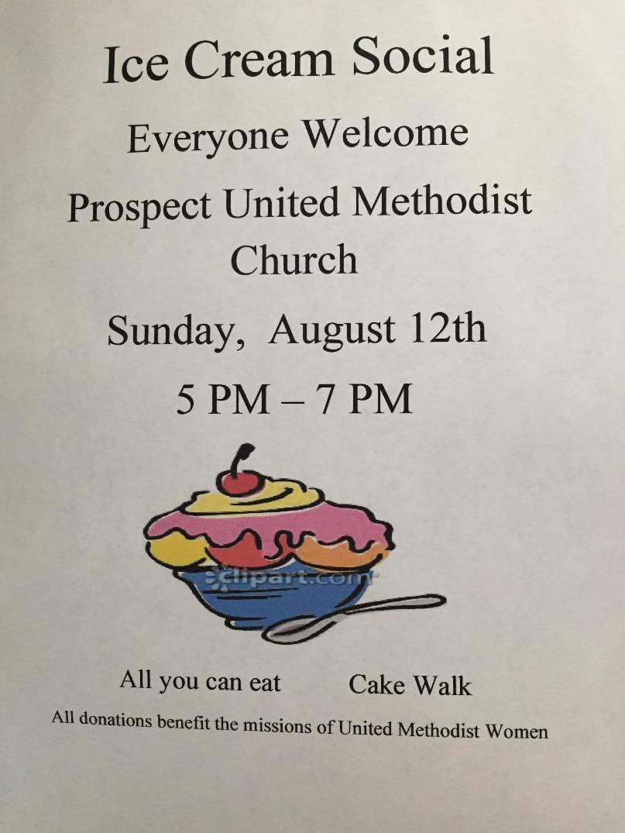
August 19th / 12:30pm – 2:30pm
Luncheon -- $10
To support the mission:
Raise the Roof
Franklin 1st - Asbury Hall
120 Aldersgate Way
Franklin 37069

Directions to Franklin First UMC

Do you have something to submit for the newsletter? Send to:
pdj1169@gmail.com

235 Main Street
Prospect 38477
Directions to Prospect UMC

